Activity 1: Understanding Inner Movies
 | List some of the inner movies you’ve had recently.

Activity 2: Side Benefits of Great Inner Movies
 | Write about an inner movie that drags you down that you’d like to replace with one that helps you calm yourself and activate your immune system.

Activity 3: Your Inner Autobiography
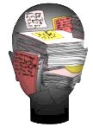 | List some things you notice about your own Inner Autobiography. Include some things that energize you for success, and some things that bring you down.

Activity 4: Recognize your fight response.
 | Write down a few examples a when you tend to get fight responses.

What does your body feel like?

What emotions do you feel?

Activity 5: Recognize your flight response.
 | Write down a few examples a when you tend to get flight responses.

What does your body feel like?

What emotions do you feel?

Activity 6: Recognize your freeze response.
 | List a few examples a when you tend to get freeze responses.

What does your body feel like?

What emotions do you feel?

Activity 7: Getting to know your Artist.
 | List some creative activities that you enjoy. Also write what other people say or do that helps get this Artist energy revved up for you.

Activity 8: Getting to know your Thinker.
 | Write down areas of your life where your Thinker is a huge help to you.

Activity 9: Understanding your inner movie.
 | Write down a few inner movies that have helped you in your life.

Write down a few inner movies that have gotten in the way of success.

Activity 10: Influencing your inner autobiography
 | What views of yourself and the world does your inner autobiography give you?

How can you rewrite portions of it over time to make it more and more empowering?

How can you help others to have more helpful, empowering inner autobiographies?

How can you help others, particularly those most dependent on you improve their inner autobiographies?

Activity 11: Self-awareness: The effects of your inner movies
 | How did the inner movies in Activity 9 affect your mood and behavior?
Helped:

Hindered:

Replace Challenge: (This is Activity 14, purposefully in a different order)
 | Write about a challenging situation in which you want to be more successful, but have some trouble motivating yourself to do what needs to be done. What limiting inner movie(s) do you have about that challenge now?

Activity 12: Identifying Your Successful Inner Movies
 | Write about a situation where your inner movie helped you succeed. Think about what you said to yourself, what you read, or what others said to you that helped create an inner movie. (Ideally choose a success that was as close to your Replace Challenge as possible. It’s okay to choose a vastly different one, just helpful if it can be similar.)

Activity 13: Energizing your Artist
 | Circle items on the following list that might energize your Artist for your Replace Challenge.
thinking about exciting goals |  | imagining the benefits of an idea | remembering any past successes | remember relevant successes
exploring creative ways to solve challenges |  | exploring enjoyable ways to get to solutions | good portion of your creative time 100% positive | examples of others who’ve accomplished your goal

List other ideas that can help energize your Artist to help you motivate yourself.

List ideas for energizing other people's Artists.

Activity 16: Calming your Caveman
 | Write down what helps you calm your Caveman the most now.

What might help you the most in the Replace Challenge?

Notice which techniques in the following list that you do well already. Circle the ideas that you might want to try for the Challenge you listed in Activity 13 (or other times).
slow, deep breathing | visualizing  calm scenes | thinking about positive traits | taking a break
reframing your “caveman comment” | meditation  prayer | exercise, stretching, dancing | scents,  music,  nurturing touch

Activity 17: Calming someone else’s Caveman
Write down the ideas that you like the best for calming someone else's caveman. (see book for ideas) Write ideas for the Replace Challenge.

Activity 18: Convince your Thinker
 | Circle ideas on this list that might help convince your Thinker to accomplish your Replace Challenge.
long-term benefits for achieving this challenge |  | how you think you’ll be able to achieve this new challenge | brainstorm multiple plans | analyze the possible consequences
create a plan overview with sequenced activities on a timeline |  | for the very next step, create a detailed plan | come up with contingency plans for negative consequences | make a pros and cons list

List other ideas that can help convince your Thinker to help you motivate yourself.

Write down ideas for convincing other people's Thinkers of needed change.

Extra activity: Self-awareness: The Chameleon Effect in your life
 | List 2+ examples of when something someone said that had a Chameleon Effect on you. Include at least one example that was helpful and one that was not. Write down what you think those effects were.

Activity 19: Improving Your Positive:Negative Ratio
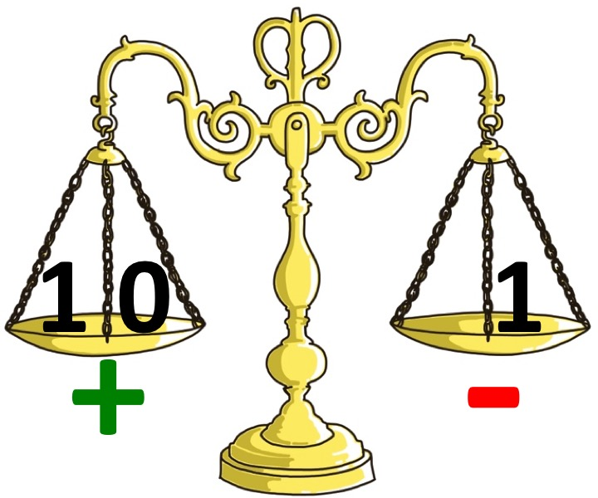 | What relationship/group would you like to improve your ratio? List positive things you can say and do to focus more on positive goals, ideas and affirmations. E.g., Smile, pat on the back, encouragement, helpful ideas, finding common ground, praise, identifying strengths, listening well, etc.

Activity 20: Priming Practice

- Write down a situation where you’d like to be more confident.

- Notice and list the unhelpful inner movies as if they have titles.

- Brainstorm as many helpful inner movie ideas as you can.

- Circle the top 1-3 inner movie ideas for the next time you enter that situation.

- Practice one of them in your own mind. Talk confidently about how you will put this in to practice with supportive friends.

- Once this inner movie feels real enough try it in the situation. Play beforehand, and during as needed.

- Keep building on what you’ve done well.

Activity 20: Improving your Positive:Negative ratio
 | Where would it benefit you to improve your ratio? (e.g., relationships, situations, groups, etc.)

List things you can say to focus more on positive goals, ideas and affirmations when your Caveman may want to start swinging its club. (see list in book for ideas)

Activity 21: Positive Change Questions for planning your next step
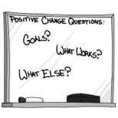 | - Goal? Write down a positive goal that you have for yourself.

2. What works?
  - List of all the things that you are already doing, and the knowledge and skills you already have that are helping you towards this goal.

  - Pick 3-5 things from your list that you feel are the most helpful. Write how you can do these even more, or even better.

(Activity 21 continued)
3. What else? Brainstorm a list of other ideas. List any idea that has the remotest possibility of helping you toward your goal. No critical editing at this time, just write it all down.

- Start one of them today, or at least this week. Once this idea has become a habit for you, add a new one. (Write this one here.)

4. Action
- Brainstorm a list of ways to direct a motivational inner movie for your goal. For example, write things that you will gain, and any other benefits of achieving this goal.

- Circle the most motivating of these ideas (that you just wrote) that you can easily do.

- Play one or two of these ideas on your inner movie in as detailed a way as you can. Make this a powerful inner movie by imagining the wonderful feelings that you will have when you accomplish your goal. Think of the good things that others are likely to say to you. Play in your mind the image of what opportunities will open up for you having achieved this goal. Play this inner movie for yourself at least three times a day.

Activity 22: Where to use Positive Reframes?
 | Write down two different areas in your life where Positive Reframes would be really helpful to you.

Create a reframe for each of these areas that might help you "direct" better inner movies. Feel free to adapt some of the examples from the book.

Activity 23: Build your skill in creating Positive Reframes
- To help yourself learn this skill, take some time right now to create five more reframes that will help you motivate yourself to act toward your goals.

Activity 24: Build your skill in influencing others
Pick the best reframe(s) from the list of reframes in the book that you think you can use to motivate others.

Create 10 new reframes that will help you be more effective.

Put a note in your calendar to reframe three things every day for the next 30 days.

Check out the free video and blog posts on reframing on my blog at bobfaw.wordpress.com (search for “reframe”)

Act Activity 25: Creating reframes together (advanced)
Get together with your team, your family, or your group, and make a list of Caveman-type comments that are detrimental to you all. Reframe them together to make more inspiring and guiding statements that will help you all move forward together.

Activity 26: Mastering Motivation – the foundation
 | 1. First list at least five ways you are already good at motivating yourself and others.

2. Now write the three most important things that you gained from this book to help you become even better at motivating yourself and others.

